WORLD SQUASH DAY

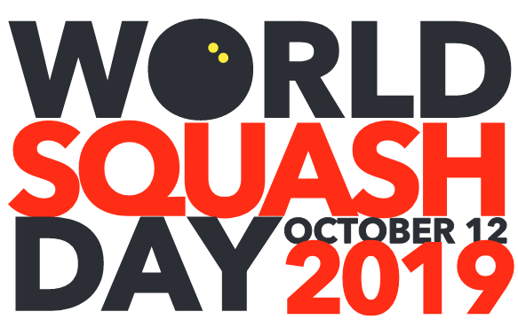

#growthegame

CELEBRATING THE 200th ANNIVERSARY
OF THE BIRTH OF SQUASH WITH MAJOR
CAMPAIGNS TO REINVIGORATE THE SPORT

A PROPOSAL FOR THE WORLD SQUASH FEDERATION

PRESENTED BY ALAN THATCHER,
Founder of World Squash Day

WORLD SQUASH DAY: Page 2

WORKING TOGETHER
TO GROW THE GAME

World Squash Day gives every club in every nation the opportunity to work together to grow this wonderful game of ours.

The following pages set out the targets for World Squash Day campaigns being launched this year and next.

As we create plans to celebrate the imminent 200th anniversary of the birth of squash, let’s use this as a focal point to attract One Million new players to the game over the next ten years.

Following the latest Olympic disappointment, it is vitally important for the sport to send out positive messages.

We know that squash is one of the greatest sports ever invented, and is renowned as the very best sport for health and fitness.

We know that squash improves mental health and helps young people to develop social skills.

We know that squash becomes a lifetime passion for so many of us.

We know that our leading players are among the finest athletes on the planet.

So, let’s all join forces on World Squash Day to promote the above messages and encourage every club, every federation and every school or college squash facility to open their doors to attract new players.

Please read on to see how we can structure a worldwide campaign to gain momentum over the next few years as we approach the 200th anniversary of the birth of squash.

WORLD SQUASH DAY: Page 3

WORLD SQUASH DAY 2019:
LAUNCHING THE BIG HIT

This year, 2019, we are planning a global campaign called
The Big Hit.

It is a very simple concept: We provide a clear structure and plan for every club and squash centre and encourage them, using this structure, to:

- Open their doors to attract new players

- Host one-off taster sessions on World Squash Day under the brand “The Big Hit”
- Keep the momentum going with a Big Hit session once a week to look after your new players
The structure will be very simple (we will produce and share sample advertising media and promotion strategies for all to follow):

- Welcome them to your facility
- Find them friends to play with
- Get them playing with the correct ball (NOT the double yellow dot ball straight away!)
- Help them to fall in love with the game the way we all have
- Then they will tell their friends and families and even more players will be flocking to the game!

WORLD SQUASH DAY: Page 4

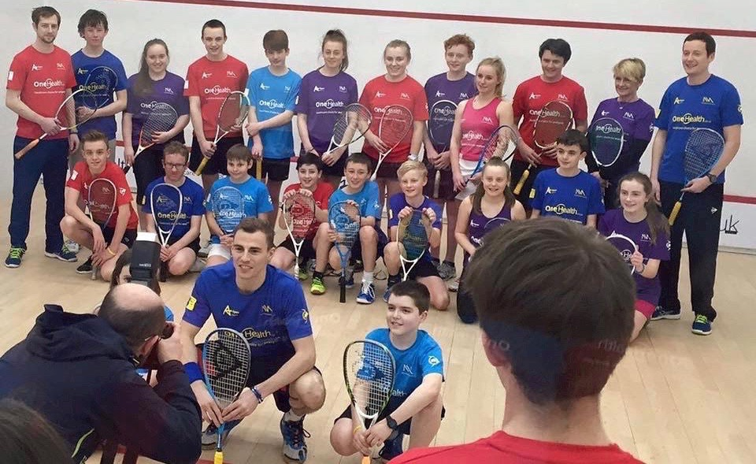
Nick Matthew and his Academy in Sheffield, England

For this to be successful, we need every squash federation to be actively involved.

We already have a powerful and positive buy-in from England Squash. They have already offered to provide incentives for clubs who register to deliver their Squash 101 and Squash Girls Can events as part of The Big Hit.

Across the UK, a number of squash enthusiasts, including former world champion Nick Matthew, have stepped forward to help create and deliver major projects on World Squash Day and I am massively grateful for their input and support.

Other nations can provide similar support mechanisms and incentives, and tailor their Big Hit programmes to suit their own regional priorities.

For example, in the USA, World Squash Day coincides with the US Open. Is this a negative? No, totally the opposite!

It gives clubs the opportunity to host an Open Day for newcomers and hold US Open Party Days, with live action on screen from Philadelphia showing newcomers how the game should be played.

It also provides an instant link between the grass roots of the game and the world’s leading players, something we should be encouraging at every opportunity.

FACT: Holding a global event supporting squash on one special day makes it easier for every club to recruit new players due to the “critical mass” of marketing messages being shared via media channels and our own networks.

WORLD SQUASH DAY: Page 5

WORLD SQUASH DAY TARGETS:

We would love to attract 100,000 new players across the planet on World Squash Day 2019 … and then achieve the same result every year for the next ten years.

Just imagine:

That’s ONE MILLION NEW PLAYERS, playing and supporting the game.

That’s one million rackets, and one million pairs of squash shoes being sold.

One million new players, spending money on booking courts, supporting their local clubs, and contributing membership fees to clubs and federations.

One million people, sharing the health benefits of our fantastic sport.

HEALTH BENEFITS:

We should all be shouting louder about the health benefits of squash: During the past two months I have been teaching a neighbour how to play. He is burning more than 1,000 calories an hour during every session. He has improved his cardiovascular fitness, lost weight, and has knocked eight seconds off his original court sprint times! And now he has got his wife and children playing…

Squash is widely recognised as the best sport for health and fitness, wellbeing, mental health, making friends, building a lifelong social network, teaching life skills to young people ... the list of benefits goes on and on.

Here’s how squash can promote those values throughout our local communities.

COMMUNITY HEALTH PROJECTS:
Squash can lead the way in creating and delivering Community Health Projects. During the daytime hours, when many clubs have empty courts, use those spaces for a wide variety of fitness activities.

Talk to schools, talk to hospitals, and large companies (especially those with a sedentary workforce) in your region. Get them all on board for the journey.

Make YOUR town, YOUR city a healthier place to live and bring up children.
All with squash leading the way.
WORLD SQUASH DAY: Page 6

GLOBAL HEALTH CRISIS 1:
The same worrying statistics occur in most countries.

By the age of 11, one in three children is showing signs of obesity.

In 2018 the World Health Organisation reported that the number of obese infants and young children (0-5) increased from 32 million globally in 1990 to 41 million in 2016.

If these trends continue, it is predicted that this number will rise to 70 million by 2025.

This is a global scandal.

Squash can lead the way in tackling this issue.

GLOBAL HEALTH CRISIS 2:
Many people stop taking any exercise when they reach "mid-life", say, the age of 45.

This lifestyle leads to all kinds of illnesses and health problems, including CHD and Type 2 Diabetes.
They are all entirely avoidable.
Again, squash can lead the way in creating and delivering health and fitness programmes to help these people lead happier and healthier lifestyles.

In England, I am talking to the government, local councils and health providers about partnership programmes with The Big Hit project.

This could lead to local or national partnerships being put in place. It may also lead to funding for community health projects.

Each nation is encouraged to hold those same conversations and create those same partnerships.

WORLD SQUASH DAY: Page 7

SQUASH: PROJECT 200

In 2020, we plan to launch SQUASH: PROJECT 200
in partnership with the World Squash Federation.

This is a major initiative to celebrate the fast-approaching 200th anniversary of the birth of squash (widely reported to have occurred at Harrow School in London, England, in 1830.)

Every national federation will be invited to take part. Your job is to encourage every regional association, and every club, every facility, to become involved.
We can use this opportunity to revive, relaunch and rebuild the game.

The idea is to launch a 10-Year Programme taking us through to 2030, when we can really do something special to celebrate the 200th anniversary!
This will be a constantly evolving project, not something that happens on one day, but it is a project that we intend to launch on World Squash Day 2020.
We want to encourage new growth. And keep building momentum year on year. As well as continuing The Big Hit project to attract a massive new wave of players, we need to work together to provide marketing solutions to sell our wonderful sport to a wider community.

BUILDING THE FUTURE OF SQUASH

As well as promoting the game of squash, we aim to encourage clubs to make better use of their facilities and use courts as multi-use spaces.

Many squash clubs find that their courts are empty for many hours of the day.

By embracing the vision to reach out into local communities, and provide a wide variety of fitness activities, clubs can be more flexible with the use of those court spaces. Those empty courts can easily be used for all manner of fitness and exercise classes.

Clubs can create spaces for badminton, yoga, dance, indoor soccer and many, many other activities that will keep the premises busy all day long.

This will generate revenues to support your squash programmes. It will also help to create wider relationships with your local communities.

WORLD SQUASH DAY: Page 8

DELIVERING SQUASH: PROJECT 200

SQUASH: PROJECT 200 will provide a platform for national federations to create their own vision for the future of squash in their own territories.

For example, in England, we intend to work with England Squash to encourage the construction of at least 200 new courts during that 10-year campaign. I am already in contact with architects, builders and court construction companies about making these projects AFFORDABLE.
The key is that clubs can realign themselves and become known as Community Health Centres .... with SQUASH leading the way.
Building squash courts with moving walls is a key objective, so that during daytime hours we can create flexible spaces for other activities. We know that Sport England look more favourably on mixed-use facilities when it comes to allocating funding.

Elsewhere in the world, every national federation can set their own targets aligned to their own population centres and existing facilities.

World Squash Day will work with the WSF to provide a suggested framework for the delivery of major projects.

The main target for us all to share is this: Increased participation figures will result in the need for extra courts.

That course of action was shared by one of Egypt’s leading coaches during a presentation held at last year’s World Squash Federation AGM in Cairo. Omar Elborolossy reported that three clubs in Cairo had 2,000 junior members between them and needed to expand their facilities to cope with the demand. That kind of success story is the kind of publicity the game needs right now.

NEXT STEPS:

My next steps for World Squash Day are to:
1: Launch a new website (domain name to follow soon) where clubs and federations can register their events. This way we can keep track of numbers.
2: Collate all the above information and ideas into a simple format for the World Squash Federation to share with every nation.
3: Plan global and local marketing campaigns prior to World Squash Day.
4: Bring on board key people in every major squash nation to lead the way.

WORLD SQUASH DAY: Page 9

MEDIA COVERAGE:
World Squash Day provides a great opportunity for clubs and federations to generate significant media coverage for themselves and the sport.
The best way to create headlines is simple: Invite local celebrities and journalists to join in the fun on World Squash Day. Invite local media companies (TV, radio stations, newspapers and websites) to send reporters, photographers and camera crews to a special Preview Day a fortnight ahead of World Squash Day to generate publicity to promote your event.
LOCAL MEDIA:
You can easily access contact details for your local media outlets with a quick Google search. As well as inviting staff from the Sports Desk, extend your invitations to reporters from the Features or Health Desk.
MEDIA TEMPLATES:
We will provide templates for a Media Release for you to share alongside your personal invitation to media outlets in your region.
COMMUNITY INVOLVEMENT:
Invite schools, youth groups, other sports clubs and major employers to take part. If your local council has a sports development unit, talk to them weeks ahead of the big day. They may well be able to offer valuable support.
SOCIAL MEDIA:
Make sure you weave a story on Twitter, Facebook and other social media platforms. Tag local media outlets in your posts. Start months ahead of the big day so that no-one can complain “they didn’t know it was on”.
Try to add images to your social media posts as often as you can. Posts with pictures always attract more attention than text messages alone.
Our Facebook page and Twitter feed are already connecting and engaging with numerous squash communities. During the early part of 2019 we announced the date of October 12th, and have already begun sharing ideas for fun events on the big day.
We would like to invite every national federation to hit the Like and Follow buttons on the World Squash Day social media pages.
One of the key elements of the Social Media strategy for World Squash Day is to ensure that every federation and club forms a “Retweet Network” – allowing us to effectively spread key messages using our connected networks.

WORLD SQUASH DAY: Page 10

PARTNERSHIPS:

The World Squash Day team is pleased to be endorsed by:
The World Squash Federation
The PSA (Professional Squash Association)
The PSA Squash Foundation
Numerous National Federations
And a multitude of clubs, coaches and administrators across the planet
+++
I would like to extend special thanks to a group of squash friends who have shown their support for World Squash Day in a variety of ways (with apologies to anyone I may have overlooked).
Peter Nicol MBE (Founding President)
Nick Matthew OBE
Howard Harding
Mike Hegarty
Mark Kelly
Laurie Maclachlan (Joint Founder)
Kristi Maroc
Laura Northeast
James Roberts
Chris Sargent
Simon Scott
Stuart Sharp
Alex Wan
James Zug
The Sword Family and Maureen Sullivan
WORLD SQUASH DAY: Page 11

HOW IT ALL STARTED:

I launched World Squash Day with some friends after the 9/11 attacks in the USA.
Many New York squash players were killed in the World Trade Center, including Derek Sword, a former Scottish junior international from Dundee.
We launched World Squash Day in their honour, and also to do something tangible for the game.
That same passion applies today.
In some countries, the need to come up with solutions to grow the game is desperately important.
We need action right now, before it is too late.
In 2012, we attracted 40,000 players who competed in one single global match to promote the Olympic Bid.
I want us all to do much, much better this year.
I believe the future of our wonderful sport is far more important than the Olympics.

I hope we can all work together to safeguard the future of our sport and I look forward to leaders coming forward from every nation to support the cause.

With very best wishes,

ALAN THATCHER
(Kent, England, April 2019)

Email: alan@squashmad.com

Phone: 44-7971 639 829

