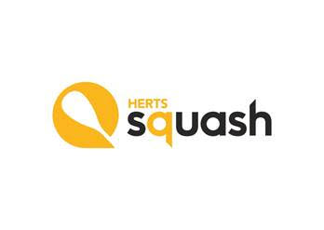

 |  | ACCOUNTS FOR 2023/4
Income account for the year ended 30 April 2024
CATEGORY |  |  | Income | Expense | Total
 |  |  | £ | £ | £
England Squash grant |  |  | 5691 | 0 | 5691
Interest |  |  | 172 | 0 | 172
Juniors
Junior championship |  |  | 1870 | 1871 | -1
Junior equipment |  |  | 0 | 175 | -175
Girls squad |  |  | 0 | 100 | -100
Junior intercounty |  |  | 0 | 1171 | -1171
Seniors |  |  |  |  | 0
County closed |  |  | 3499 | 2763 | 736
Intercounty (Mens) |  |  | 0 | 790 | -790
Intercounty (Ladies) |  |  | 0 | 550 | -550
Leagues |  |  | 2000 | 490 | 1510
Racketball intercounty registration |  |  | 0 | 200 | -200
Trophies /engraving |  |  | 0 | 102 | -102
Website |  |  |  | 180 | -180
Income over expenditure |  |  | 13232 | 8391 | 4841
Balance sheet as at 30 April 2024
Current account balance as at 1st May 2023 |  |  |  | 61
Current account balance as at 30th April 2024 |  |  |  | 7694
Savings account balance as at 1st May 2023 |  |  |  | 15056
Savings account balance as at 30th April 2024 |  |  |  | 12228
Total assets as at 1 May 2023 |  |  |  | 15117
Total assets as at 30 April 2024 |  |  |  |  | 19922
I confirm that the above report is a true reflection of the finances of the Hertfordshire
Squash Rackets Association for the year ending 30th April 2024
Louisa Dalwood
Treasurer
Eamonn Price
Chairman
Date |  | 10/06/2024

